Math 15

Homework Assignment

Read sections 13.7 – 13.10

- The article “Crop Improvement for Tropical and Subtropical Australia: Designing Plants for Difficult Climates” (Field Crops Research, 1991) gave the accompanying data on x = crop duration in days for soybeans and y = crop yield in tons/hectare.

  - Draw a scatterplot of the raw data and a residual plot. Give interpretations of both.

The scatter plot has a strong negative slope implying that there is a strong negative linear relationship between the two variables.
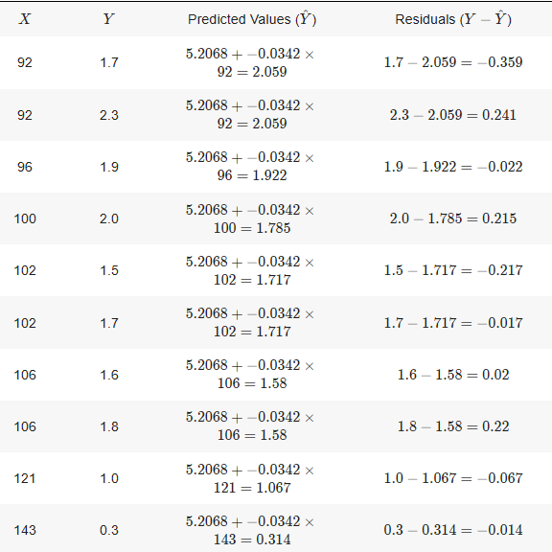
Based on the table obtained above, the following the following residual plot is obtained (residual versus observation number)

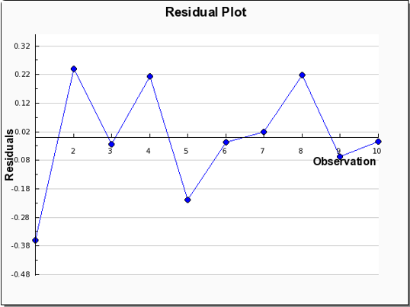

The residuals do not follow any pattern when plotted implying that there is a relationship between the two variables.

  - Conduct a hypothesis test for β . Give the p-value and statement about whether the linear relationship is statistically significant.

Solution
Under this test the null and alternative hypotheses are,
$$H_{0}: β=0 \\ H_{1}: β≠0$$
Taking the level of significance as $α=0.05$
To test the hypothesis, the test statistic is given by,
$t=\frac{b_{1}}{SE_{b_{1}}}\sim t_{n-2}=-\frac{0.03}{0.004}≈-7.7679$
From the above output we have the test statistic value as$t≈-7.7679$ and the corresponding P-value is (P<0.0001). Since the P-value is less than the given level of significance 0.05 we reject the null hypothesis and conclude that the linear relationship is significant.

  - Identify any outliers and describe the effect they may have on the analysis.
Solution
From the scatter plot, the outliers are: (121,1.0) and (143,0.3)
They increase the slope of the scatterplot

  - Give an explanation of the coefficient of determination.
$R^{2}=0.8829,$ It implies that 88.29% of the crop yield is explained (can be accounted for) by the crop duration.

  - Give a 95% prediction interval estimate for the crop yield corresponding to a crop duration of 105 days.
Solution
The regression equation is:
y = -0.0342x + 5.2068,
when x=105:
95% CI will be (4.12, 6.29)

- The PJH&D Company is in the process of deciding whether to purchase a maintenance contract for its new word-processing system. The company feels that maintenance expense should be related to usage, and it has collected the following information on weekly usage (hours) and annual maintenance expense:

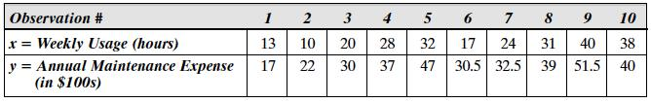

  - Sketch the scatterplot for regressing y on x . Be sure to label your axes and circle on your plot Observation #4.
Solution

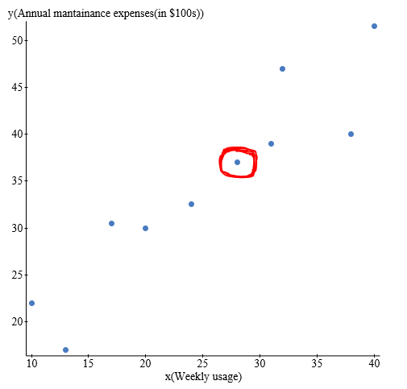

  - Find the equation of the least squares regression line for regression y on x.
Solution
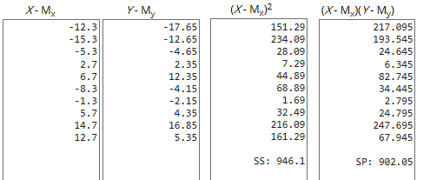
Calculation Summary
Sum of X = 253
Sum of Y = 346.5
Mean X = 25.3
Mean Y = 34.65
Sum of squares (SS_{X}) = 946.1
Sum of products (SP) = 902.05
Regression Equation = ŷ = bX + a
b = SP/SS_{X} = 902.05/946.1 = 0.95344
a = M_{Y} - bM_{X} = 34.65 - (0.95*25.3) = 10.52796
ŷ = 0.95344X + 10.52796

  - Draw (or superimpose) the regression line in part (b) on the scatterplot in part (a).

Solution
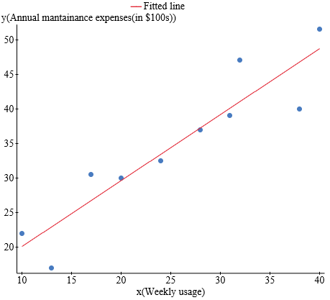

  - Suppose that the weekly usage for a company is 21 hours. Predict their annual maintenance expense. Show your work and include your units.
Solution
The regression equation is: ŷ = 0.95344X + 10.52796
When x=21,
ŷ = 0.95344*(21) + 10.52796
ŷ = 30.55
annual maintenance expense = 30.55 (in $100s)

  - Using the new word-processing system incurs other expenses besides maintenance costs. Suppose that weekly utility costs, C , in dollars, is related to weekly usage by the following equation: C = 3 X - 0.80. What would be the correlation between weekly utility cost, C , and annual maintenance cost, Y?
Solution
C=3x-0.80---(i)
Y=0.95+10.53----(ii)
From (i) and (ii) , $x=5.53 and y=15.78$
Correlation:$\frac{5.53}{15.78}$
$$≈0.35$$

  - Sketch the residual plot on the basis of this regression analysis. Be sure to label your axes and circle on your plot the residual for Observation #4.

Solution
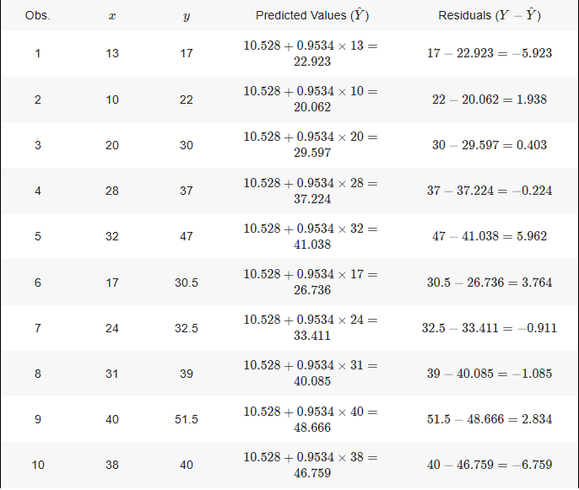

Based on the table obtained above, the following the following residual plot is obtained (residual versus observation number)

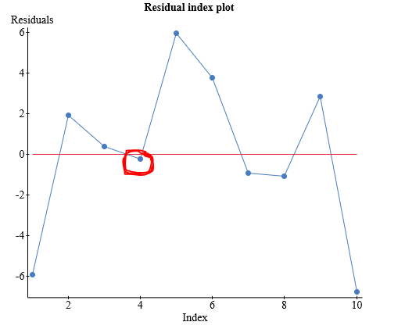
  - Based on the residual plot, does the linear model seem appropriate? Explain.
Solution
Yes, the linear model seems appropriate. This is because there is no clear pattern or trend in the residuals.

